
We have broken ground !!
I am so excited to announce that we have broken ground on our Retreat House Building Project. After much prayer and consideration, instead of holding out to build the community centre, I received Word to start with the existing house. We will be renovating the front section of the house which will include, the lounge, dining room, kitchen, passage and 2 bathrooms. We will also be painting the exterior of the house as well as the roof, and we will be working on the gardens. This will allow us to start making use of the facilities for day functions and so the Kingdom work will begin.
The house is fully packed with furniture and décor items that we’ve collected over the last couple of years and so the first job was to move everything out of the areas we need to work on, and to somehow make them fit into the other rooms (a miracle in itself). We also cleaned as much as we could and laid new rat traps.
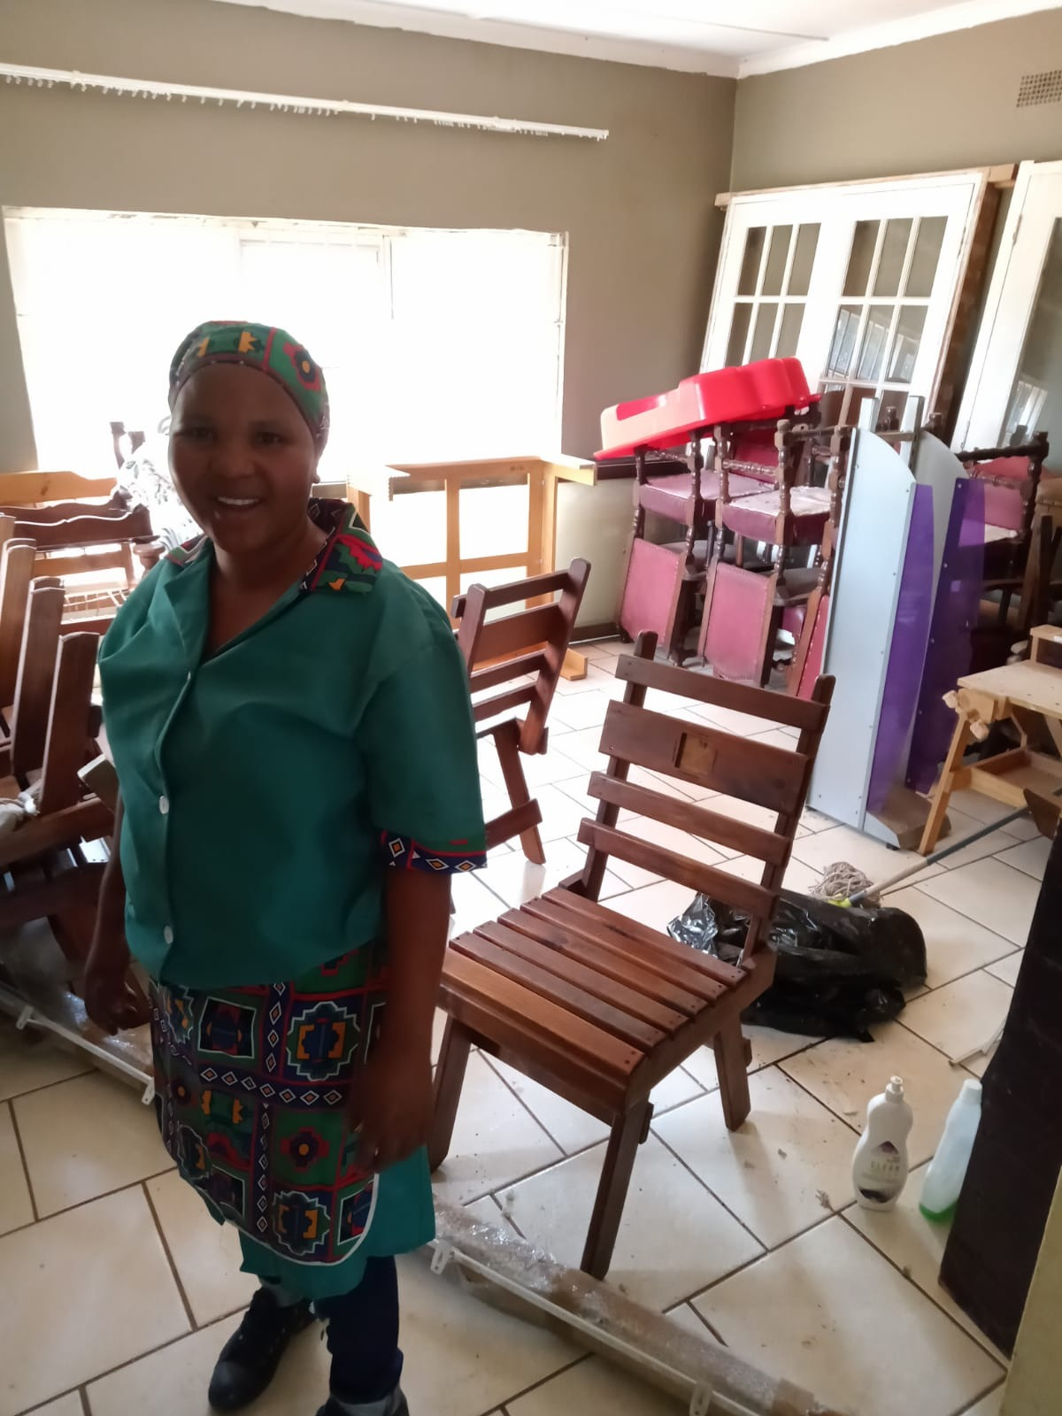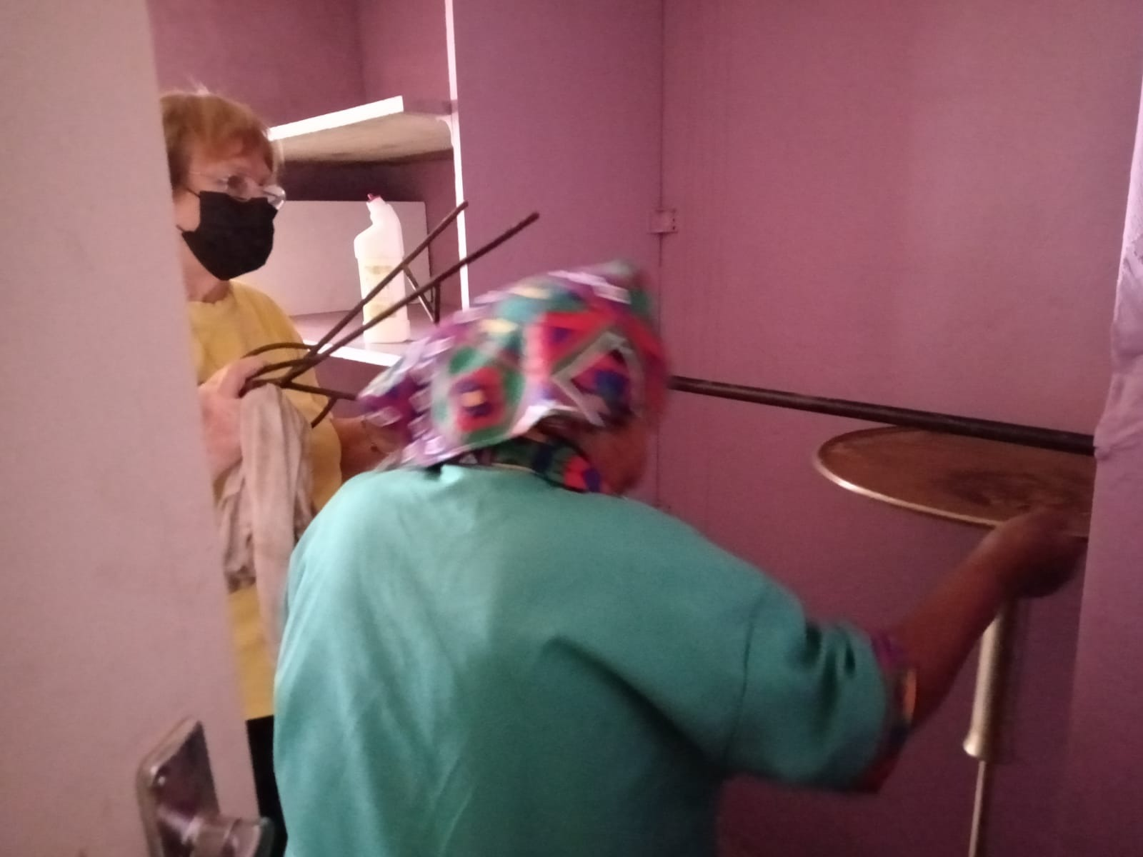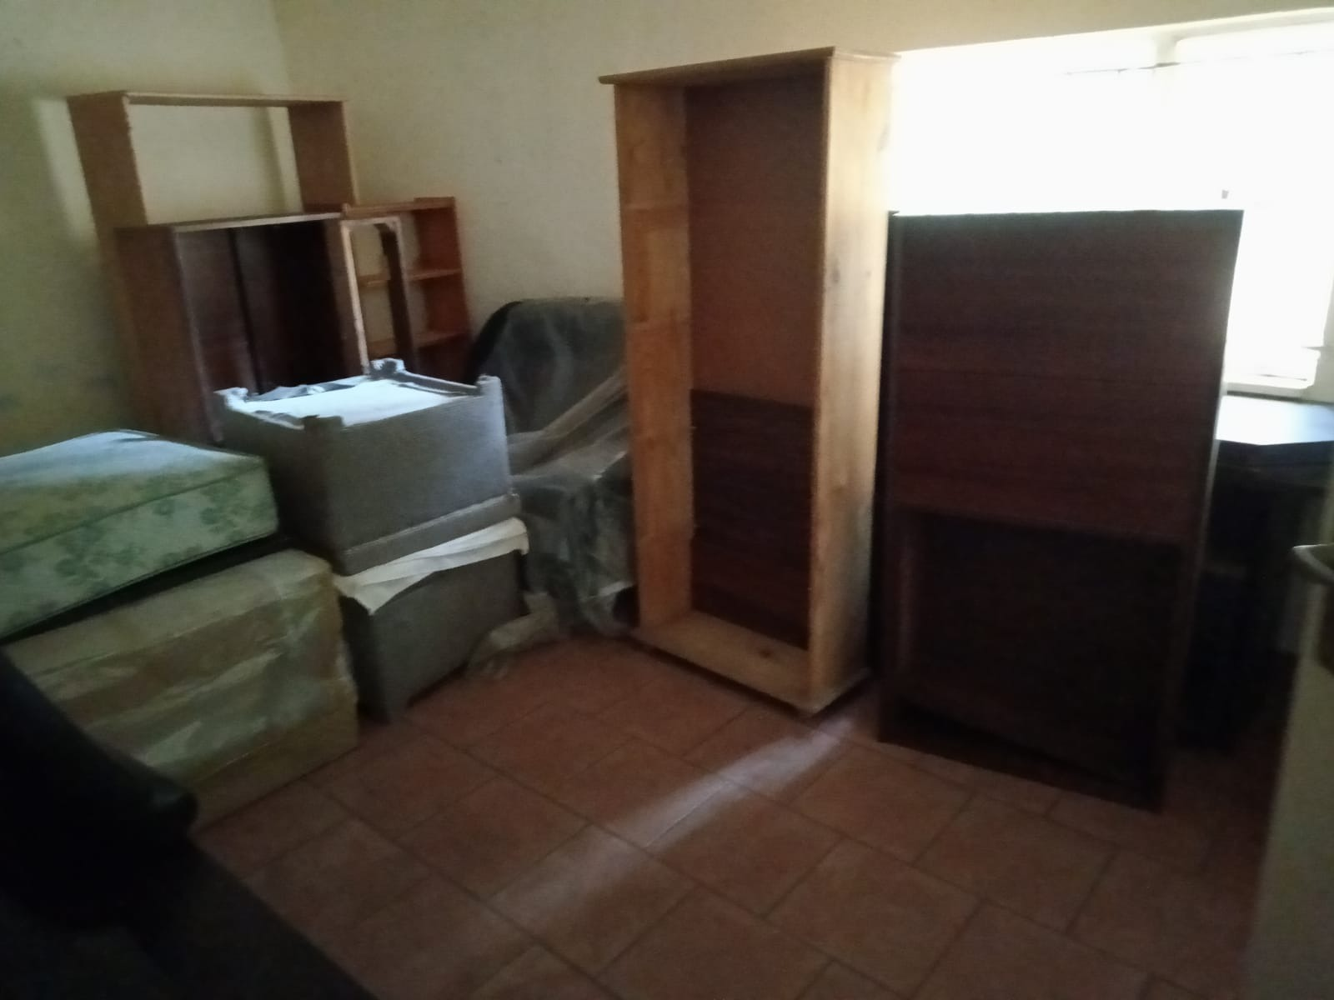

The next job was to break out the tiles and slasto in the project areas and were we in for a big surprise.
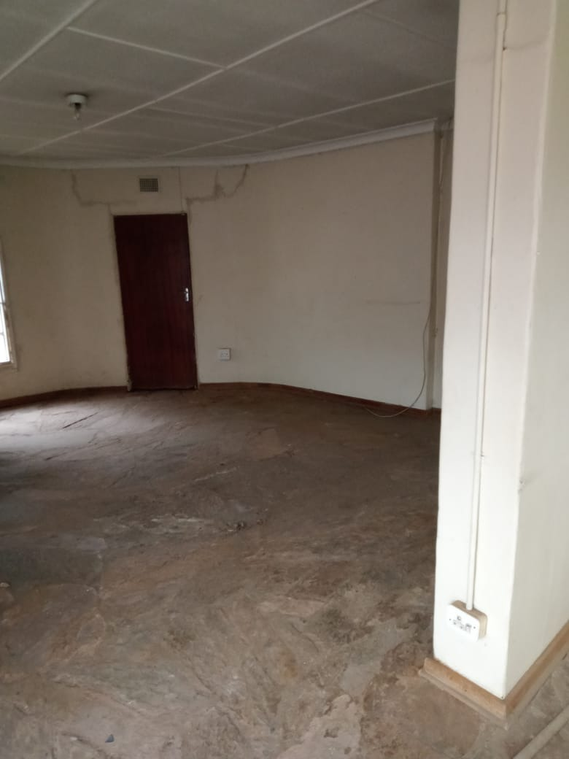 | 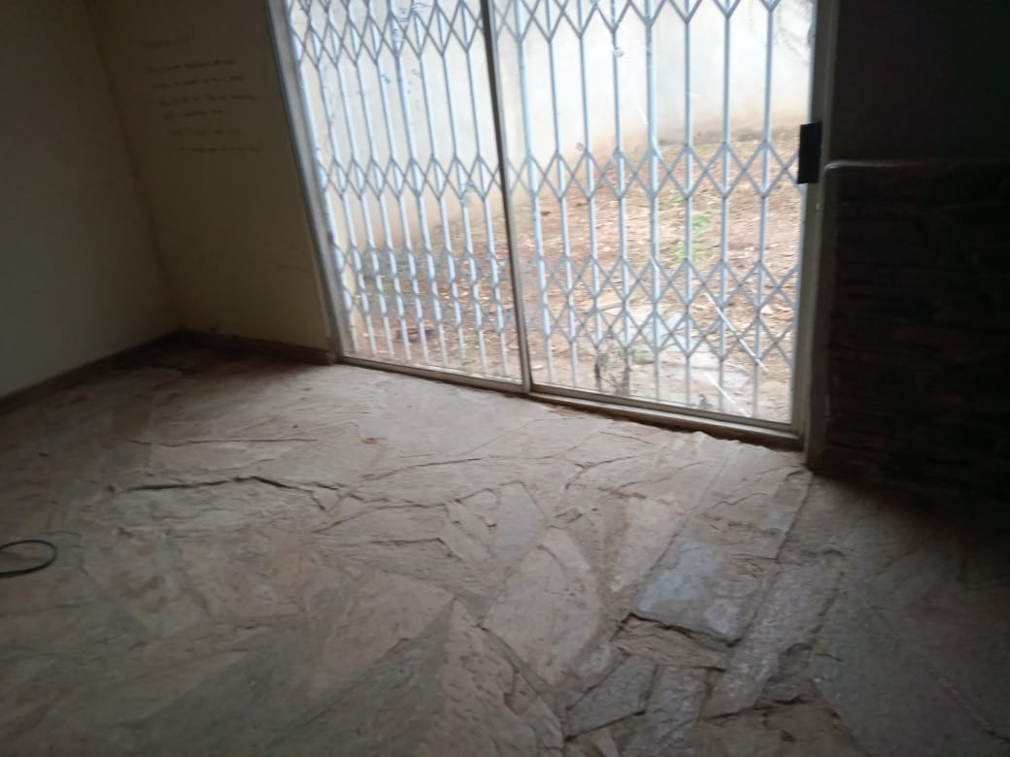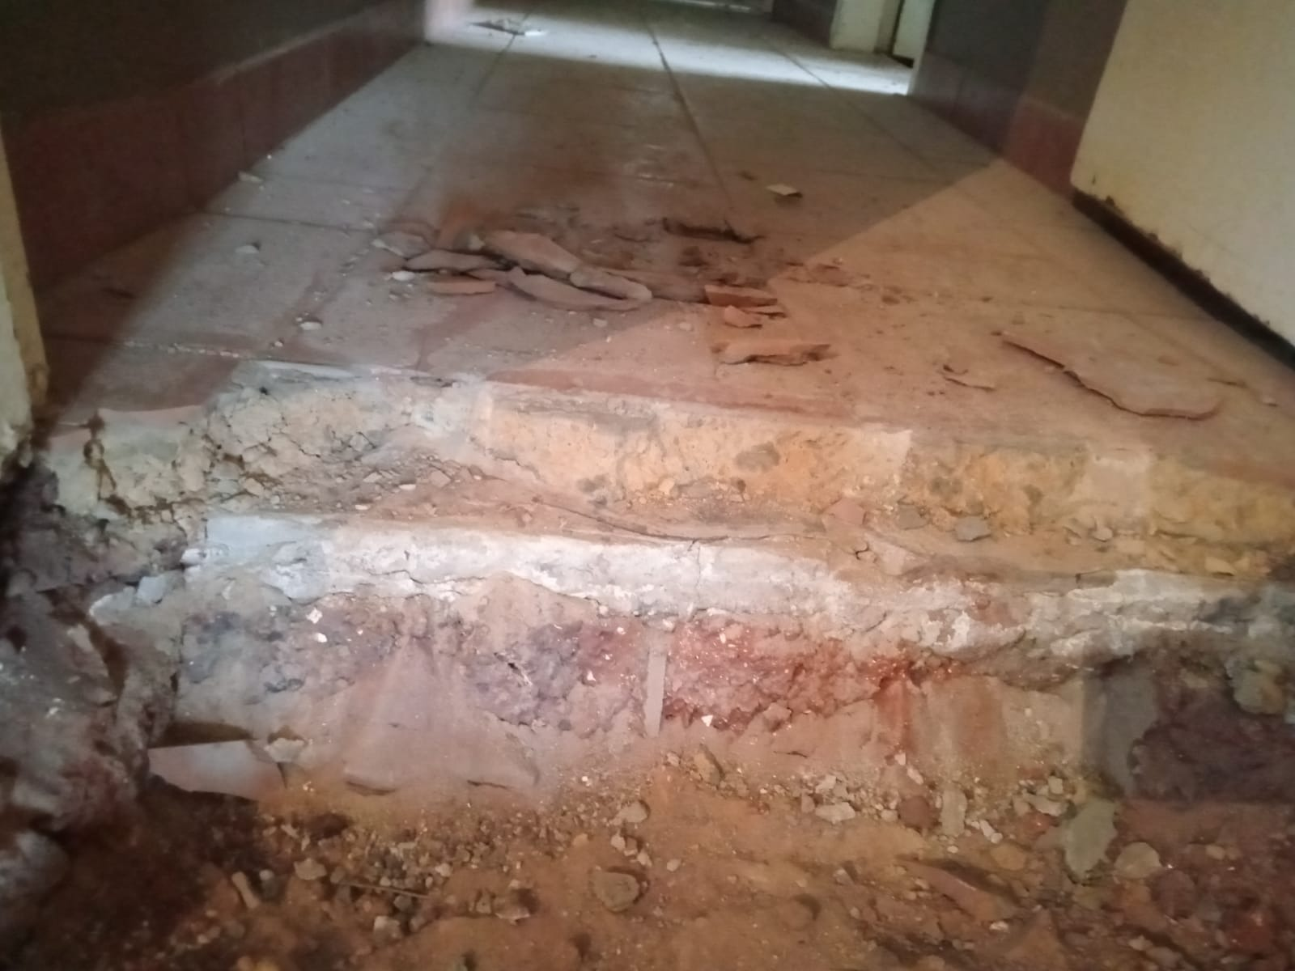

The concrete below the slasto in the lounge and dining room sections was extra thick, but even more perplexing was that the kitchen had 3 layers of tiles, each laid on thick concrete. This has been a huge task and our staff have been amazing in their perseverance. But I think it is a blessing in disguise because it has revealed a damp problem which we can now address and fix properly.
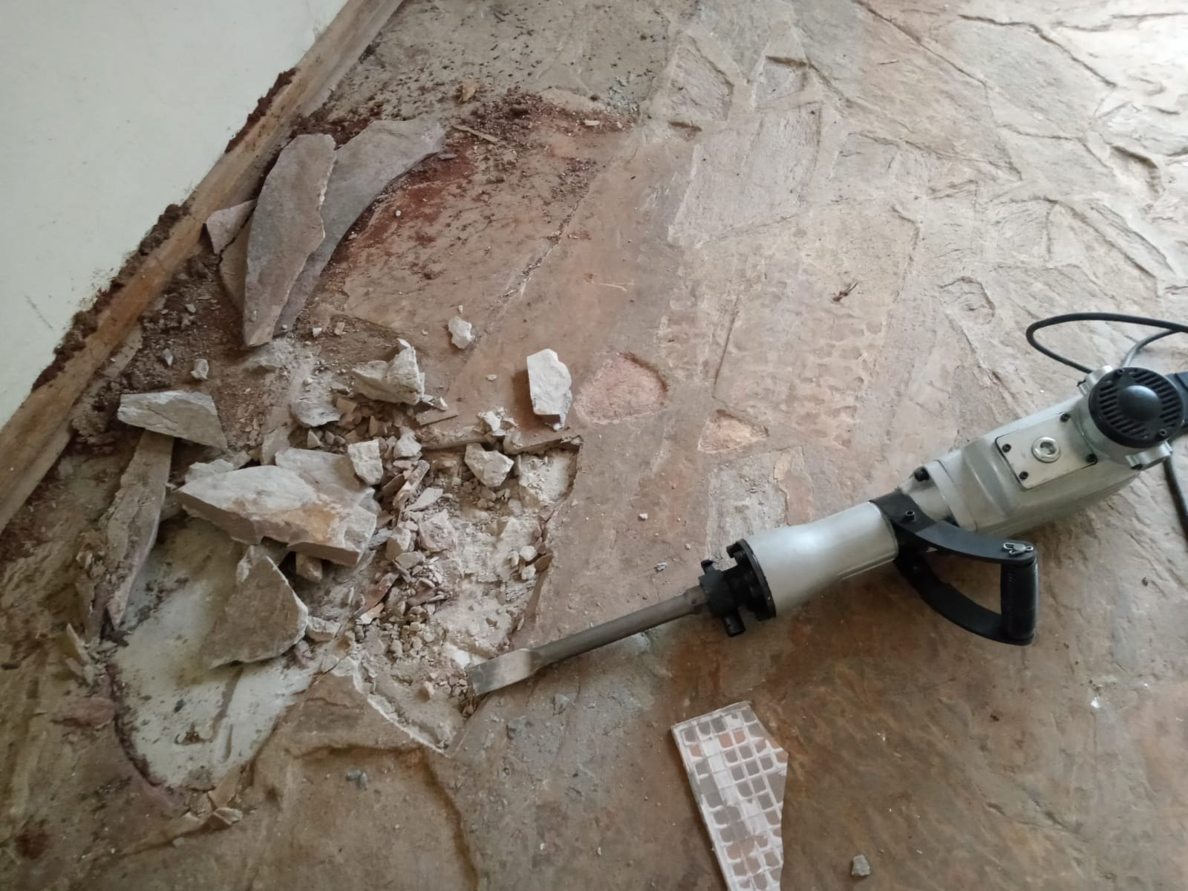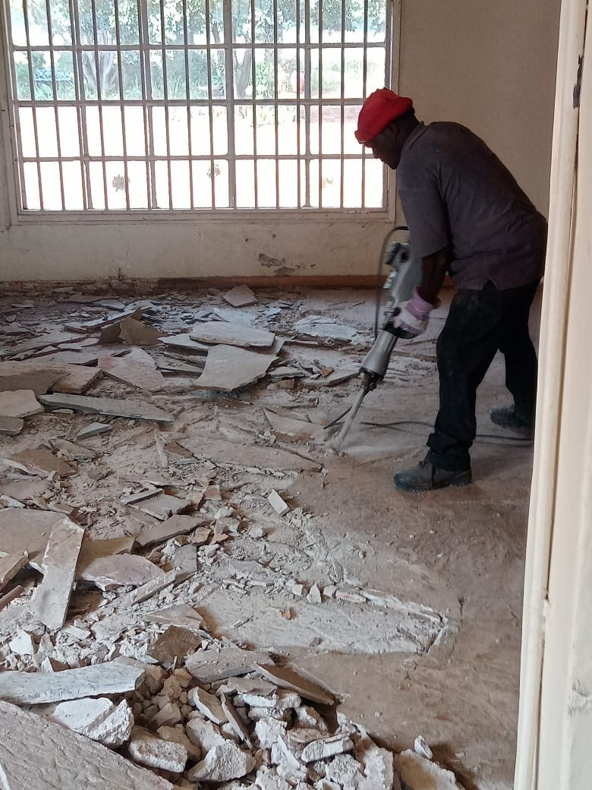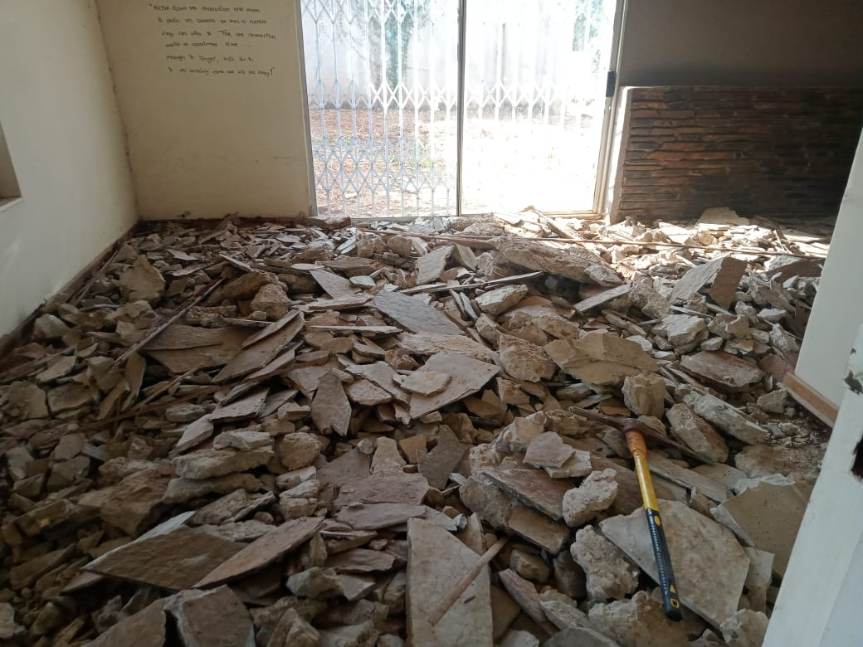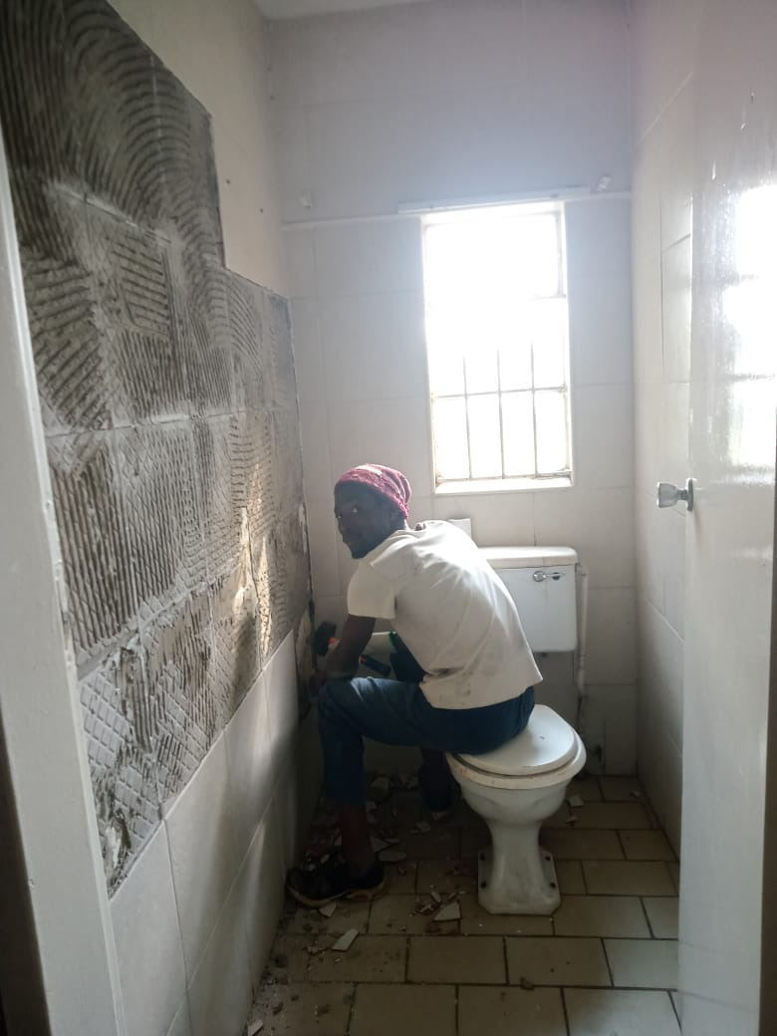

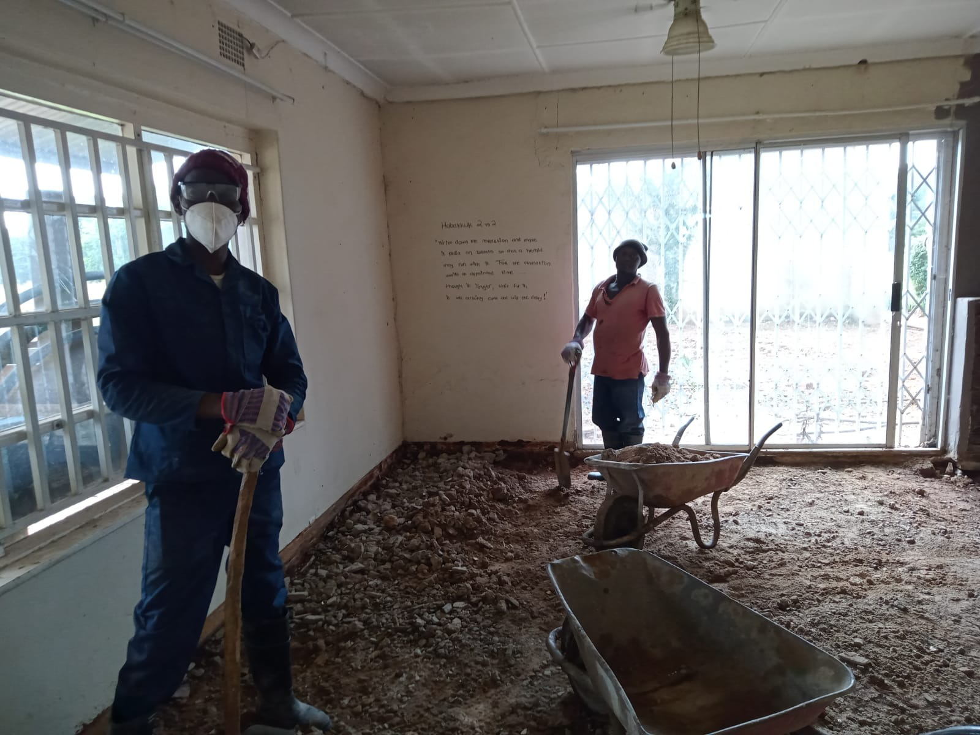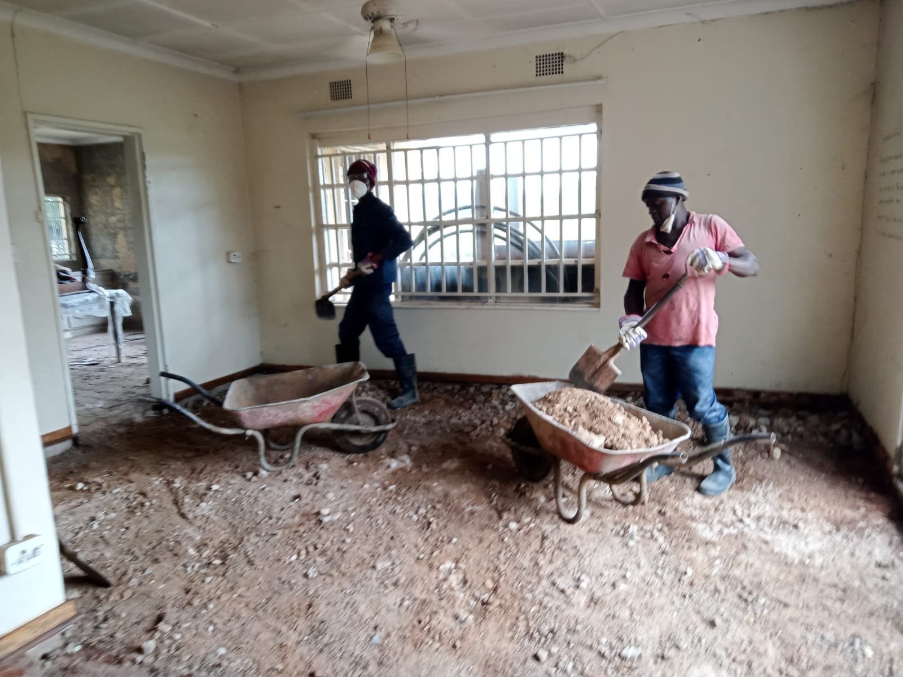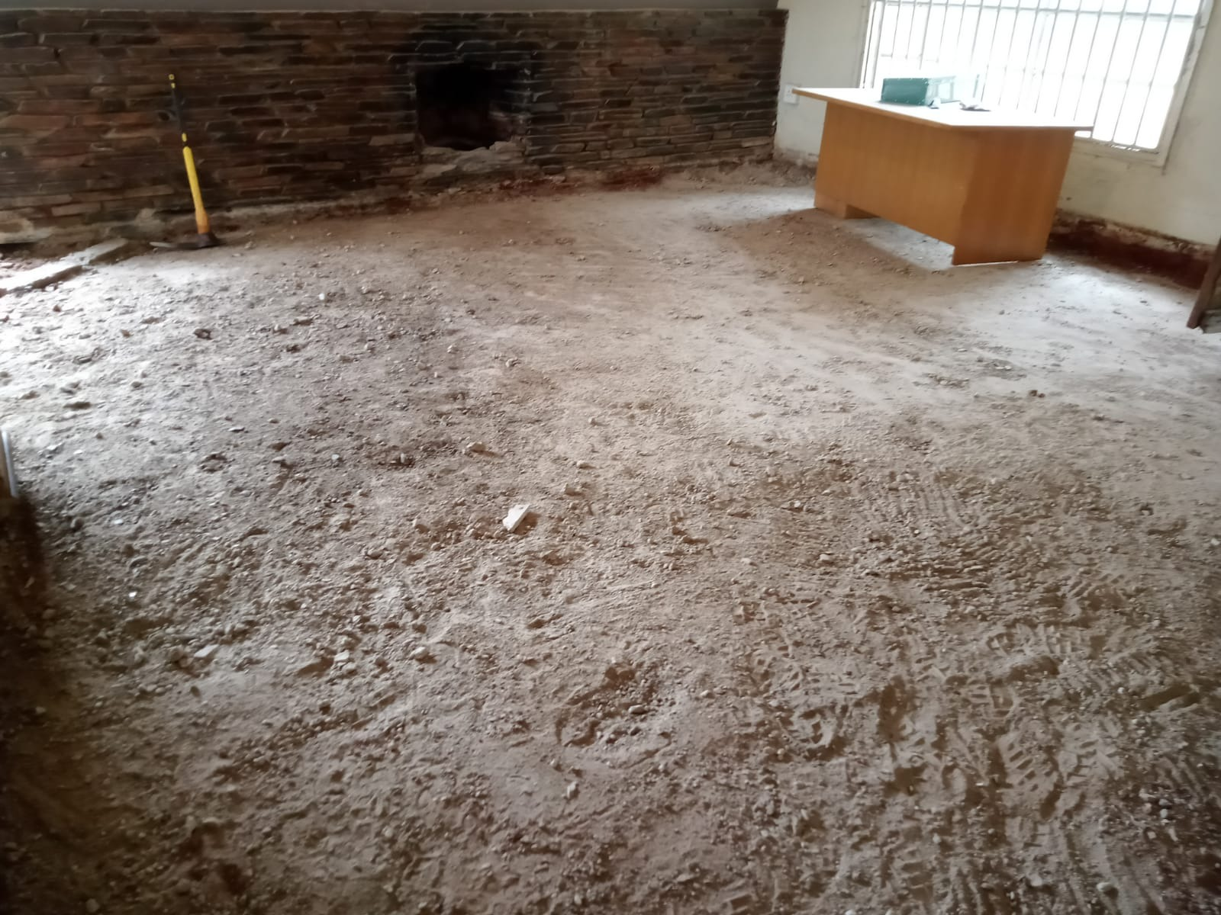
We are so grateful for all the contributions from our partners – we could not do any of this without your loyal support and will keep you posted on our progress.
With Love
Theresa

