December 2022 Newsletter  Sojourn Retreat House  Plot 98 Alweynspoort, Eikenhof  T: 084 702 4313  Dear valued partner,  This is our last newsletter for 2022 and as I prepare the content and reflect on the past year, it has been such a fulfilling journey. To date we have raised almost 5% of the target amount we need to build and renovate and although it is not yet enough to start the actual building of the community centre, we are confident that things will move quickly next year and we will keep you posted of the progress, every quarter.  Some exciting news is that………………………………  OUR WEBSITE IS LIVE  www.sojourn.org.za  AND  OUR FACEBOOK PAGE IS LIVE  https://www.facebook.com/SojournRetreatHouse  Please like, share and follow  Should you be missing our short weekly devotional, which we post on both Whatsapp and Facebook, please contact me on (0847024313) so that I can add you to the distribution list.  LATEST NEWS  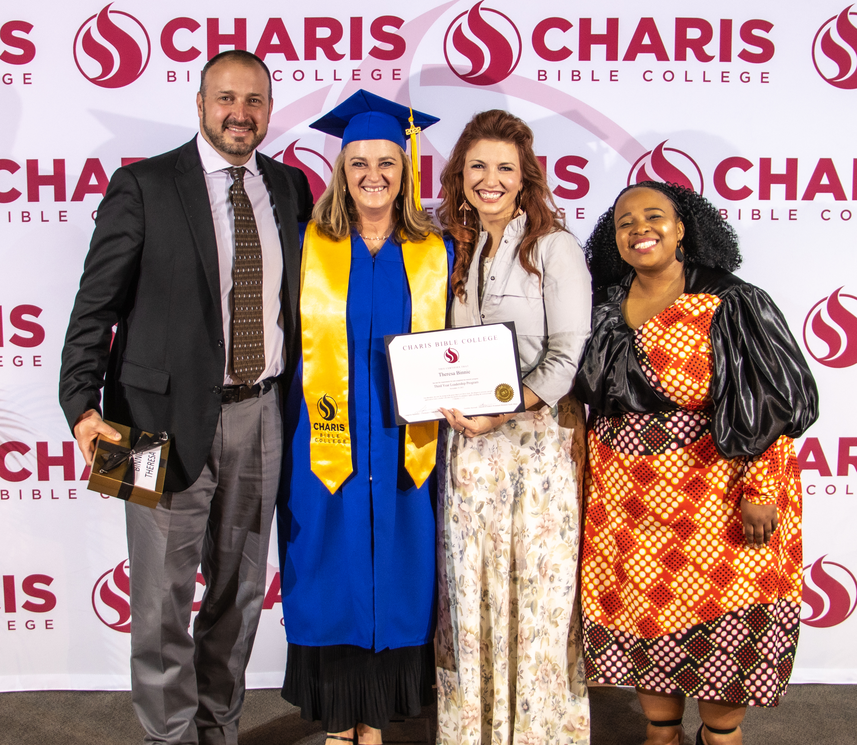  On the 19th of November 2022 I was awarded my qualification in Biblical Studies through Charis Bible College. This marks the end of a 3 year learning journey and it has been life changing. I would highly recommend this course to anyone who wants to change the world.  EVENT FEEDBACK  Sojourn hosted a dream workshop, presented by Zayin Charitable Deeds Ministry, on Saturday 8th October 2022.  The event took place in the garden under a huge oak tree and it was such a special day.  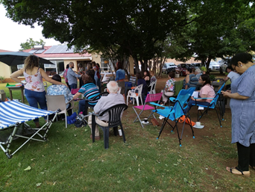  Evelyn Monteiro started off by teaching on different types of dreams and after a coffee and snacks break, Ryhan Monteiro gave practical examples of how dreams have led and guided them as a couple.  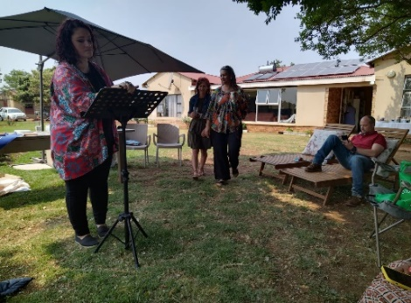  They showed how God not only uses dreams to communicate purpose and destiny but that He is also able to warn us of things to come so that we can be prepared. They taught how to interpret dreams through prayer and the Holy Spirit and then came powerful ministry time where they prayed for those in attendance and gave Word.  We would like to wish you and your loved ones a Merry Christmas filled with love. May you get to rest well over the festive season and we cannot wait to serve you in 2023. Thank you for all your prayers and support over the past year – we love partnering with you. See you next year!! | 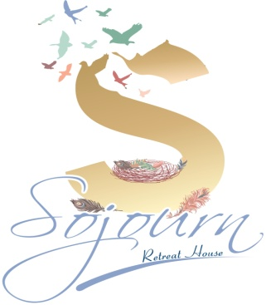  VISION  TO PROVIDE THE PERFECT ENVIRONMENT FOR PEOPLE TO ENCOUNTER GOD AND HEAR THE GOSPEL.  EQUIPPING PEOPLE, THROUGH TEACHING, TO SPREAD THE GOSPEL  BANKING DETAILS  SOJOURN RETREAT  FNB – CHEQUE ACCOUNT  62086040129  REFERENCE : YOUR NAME  Every cent gets us closer to our goal . Please consider becoming a monthly or once off donation partner.  DECEMBER GARDEN DRIVE  We will be focusing on the Sojourn gardens in Dec and Jan and will be collecting any pre - loved, garden furniture, plants or anything useful or pretty that can be used in a garden. We would love to source a zozo hut and multiple benches to be used in the design of a prayer walk. We are also looking for a shipping container. Should you have anything you’d like to donate, please let us know. We will collect.  TESTIMONIES  ‘IN THE PAST, WHEN I’VE HAD A NIGHTMARE, I WOULD IMMEDIATELY DEAL WITH IT THROUGH SPIRITUAL WARFARE THINKING THAT IT WAS EVIL. TODAY HAS TAUGHT ME THAT THESE DREAMS COULD BE GOD WARNING ME ABOUT SOMETHING AND THAT I NEED TO PROPERLY DISCERN MY DREAMS. I FOUND THE WORKSHOP VERY HELPFUL”  PATRICIA  “SITTING IN THE GARDEN WAS SO PEACEFUL, IT MADE ME THINK OF HOW JESUS TAUGHT IN BIBLICAL TIMES” T  “DIT WAS AWESOME TEACHING VIR MY GEWEES EN REVELATION OP BAIE DROME WAT EK AL GEHAD HET. EK WAS EEN VAN DAAI WAT DROOM BOEKE HET MET SYMBOLS MAAR NOU IS EK VRY OM HEILIGE GEES EERDER TE VRA” MARINDA  “THE COURSE WAS ABSOLUTELY AWESOME…. IT REALLY SHOWED ME AND REMINDED ME THAT I AM SOMEONE THAT GOD LOVES TOO. I NOW REALLY TRY AND REMEMBER MY DREAMS AND LOOK FOR THE MESSAGES IN THEM”. NATASHA  “THANK YOU SO MUCH. I REALLY ENJOYED SATURDAY. IT WAS AWESOME TEACHING AND MINISTRY TIME. I ENJOYED THE TEACHINGS. IT RESONATED WELL WITH MY SPIRIT AND I FOUND IT TO BE BIBLICALLY CORRECT” LINDIE  In 2023 we will be hosting a monthly day retreat along with art workshops – follow us on Facebook so you don’t miss out.  .

