MAY 2023 Newsletter  Sojourn Retreat House  Plot 98 Alweynspoort, Eikenhof  T: 084 702 4313  Dear valued partner,  We are so excited to share all our news with you this month. The most exciting of which is that we have finally broken ground!!! After much consideration and prayer, the project plan has changed and we have started renovations to the front part of the house instead of building of the community centre. This will allow us to start making use of the facility for day retreats and functions which will provide us with the opportunity of generating income sooner along with good exposure.  You will see that all the prep has been completed and we are now ready to begin renovating. The first task will be to rewire the electrical and to redo the plumbing. We will then seal the ceiling after which we plan to throw the slab so that we can tile and paint.  EVENT FEEDBACK  Day Retreat - In Christ – A new spirit 25 March 2023  When Jesus died on the cross He made so much available to us as born again believers. When we read the Word we begin to realise who we are and what we have in Christ. This retreat was a foundational teaching that looked at the fact that we are made up of 3 parts : Spirit, Soul and Body. How these relate to each other. That our spirit is transformed the moment we are born again and what that means for us.  We were ecstatic with the attendance and outcome.  Testimonies  I loved the fellowship with other Christians and to learn truths. CM  The teaching was good, the food was delicious and it was a blessed day. MD  I didn’t know what to expect but really enjoyed the teaching and meeting all the other people that attended. I will definitely be back. Thank you. DB  Thank you for Saturday, it was really precious. The ladies that I brought with me, some have been struggling and your absolute fervour and passion was such a blessing to them. We look forward to the next retreat and hope it’ll be in the new building. We pray that the Lord will just bless the vision that you have. KS  Day Retreat - In Christ – We have authority 27 May 2023  This was a powerful teaching  We looked at what authority we have as born again believers. This is probably the most misunderstood aspect of our Christian walk  Once again it was well attended and the feedback has been amazing.  Testimonies  What an incredible day. I learnt so much. The food was delicious and the fellowship so special. Thank you. LV  So baie dankie vir Saterdag, dit was n absoluut seen vir my!!!! Ek het so baie geleer !!!  Vandag was absoluut awesome. Ek’t so baie geleer. MdP  Thank you for your teaching today. Really good stuff! You are doing such good work. PM  Please see our note on upcoming events and of course the launch of our new pop ups. An opportunity for you to host your friends and family in the comfort of your own home where we will provide solid teaching and the opportunity to discuss some really good topics. These are exciting times and what a privilege to be able to share and enjoy the gospel. See you there.  OUR WEBSITE IS LIVE  www.sojourn.org.za  AND  OUR FACEBOOK PAGE IS LIVE  https://www.facebook.com/SojournRetreatHouse  Please like, share and follow  Should you be missing our short weekly devotional, which we post on both Whatsapp and Facebook, please contact me on (0847024313) so that I can add you to the distribution list.  PRAYER REQUESTS WHATSAPP 0847024313 | 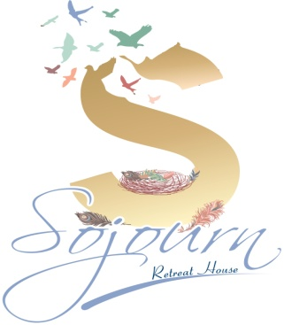  VISION  TO PROVIDE THE PERFECT ENVIRONMENT FOR PEOPLE TO ENCOUNTER GOD AND HEAR THE GOSPEL.  EQUIPPING PEOPLE, THROUGH TEACHING, TO SPREAD THE GOSPEL  BANKING DETAILS  RETREAT KINGDOM BUILDERS  FNB – CHEQUE ACCOUNT  63041139387  REFERENCE : YOUR NAME  Every cent gets us closer to our goal . Please consider becoming a monthly or once off donation partner.  UPCOMING EVENTS 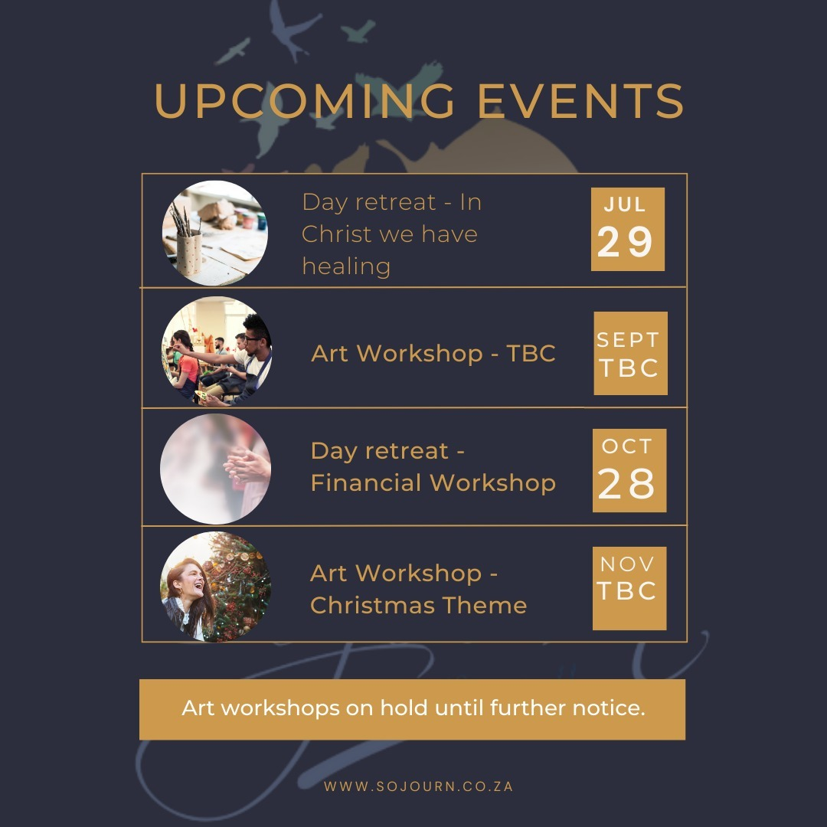  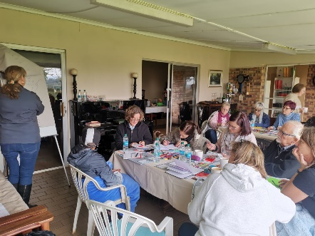  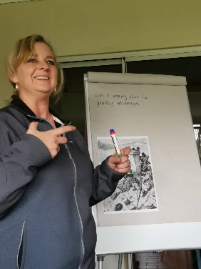  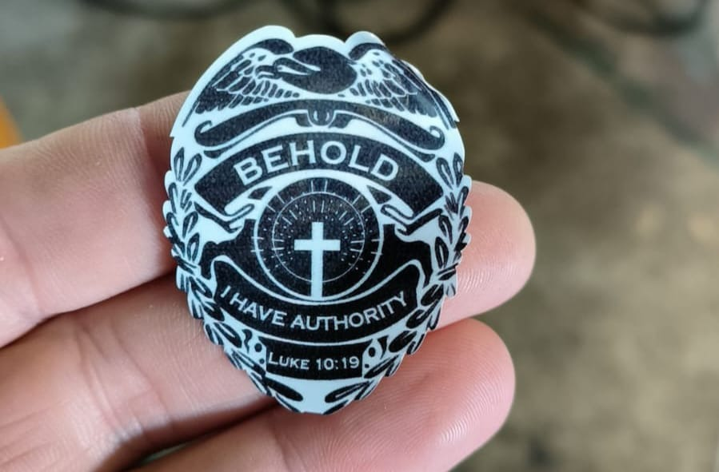  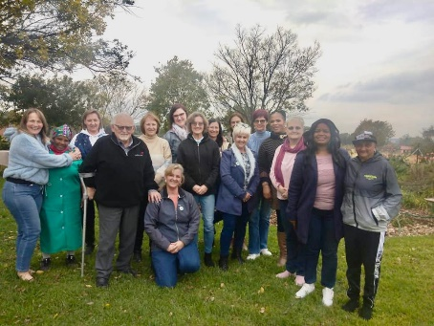    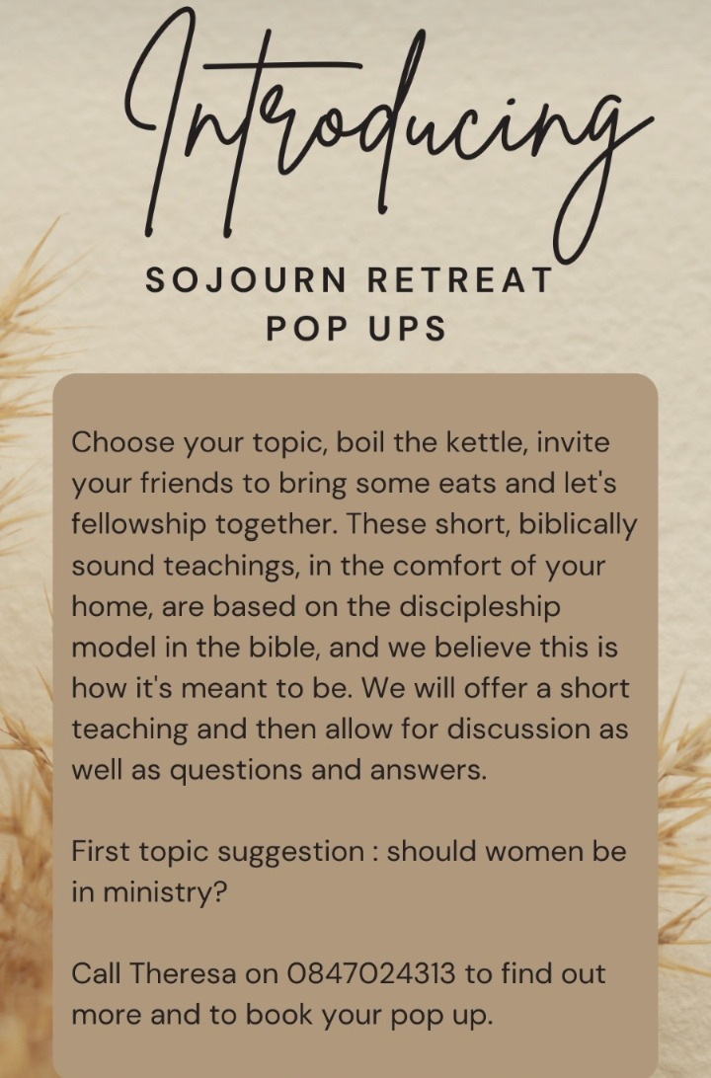  Thank you to all our partners – whether through financial donation or prayer – we cannot do any of this without you.
  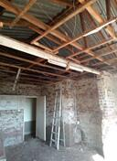 | 
  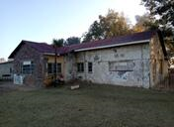 | 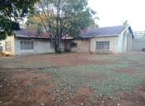
  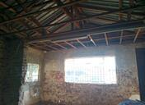 | 