Sept /Oct 2023 Newsletter  Sojourn Retreat House  Plot 98 Alweynspoort, Eikenhof  T: 084 702 4313  Dear valued partner,  What an incredible 4 months its been. As you know, we have been so eager to get started with our building project and for over a year we painstakingly tackled whatever small jobs we could in an attempt to get the ball rolling. And then in the beginning of August, as I read the story about Solomon and the building of the temple in 2 Chronicles 2, I noticed in verse 7 that Solomon asked King Hiram, the King of Tyre, to send him a good craftsman. The king subsequently sends him what he refers to as “I am sending you Huram-Abi, a man of great skill…..He is trained to work in gold and silver, bronze and iron, stone and wood, and with purple and blue and crimson yarn and fine linen. He is experienced in all kinds of engraving and can execute any design given to him. He will work with your skilled workers and with those of my lord, David your father“. Take note of his extensive range of skills. I then spread my plans before God, just like Hezekiah did with the letter he’d received, and asked for my very own Huram.  On the 5th August, after placing a whatsapp ad, (something I’ve done before without any success) God sent us our very own ‘master craftsman’, Derek. A couple of weeks later and look at the incredible progress. Nothing short of supernatural. GOD IS SOOOO GOOD. (Please see our facebook page for the latest update photos).  Our original plan was to renovate the lounge, dining room, kitchen and bathrooms so that we could start utilizing the area and generate the income needed to renovate the rest of the existing house which included the bedrooms – both existing and additional. However, on closer inspection, we discovered that 3 of the main external wall foundations had collapsed and that meant that we needed to rebuild them. At first it sounded like the worst news ever, but has turned out being the best thing that could happen. Not only do we have brand new walls with firm foundations but it has afforded us so much extra space that we no longer need to build on the additional 4 rooms. Each room now also has an en-suite bathroom which is another unexpected development. But the most exciting part of all is…………that we are going to complete the whole house renovation meaning that we will be able to host stay over events a lot sooner than expected. Isn’t that wonderful ? God is so extravagant and had a much bigger plan in mind.  External walls  Remember the single kitchen wall ? Rebuilt.  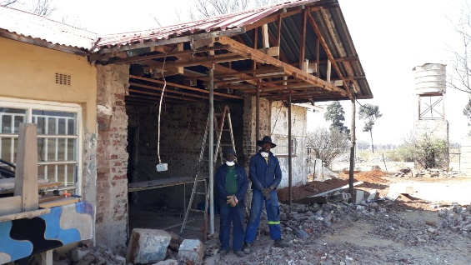  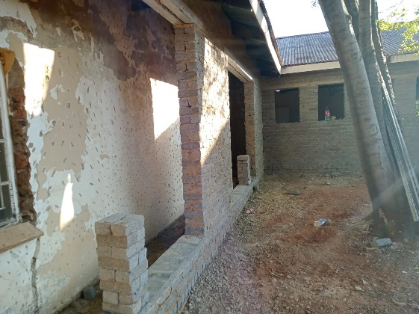  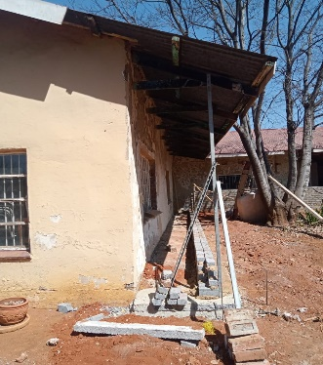  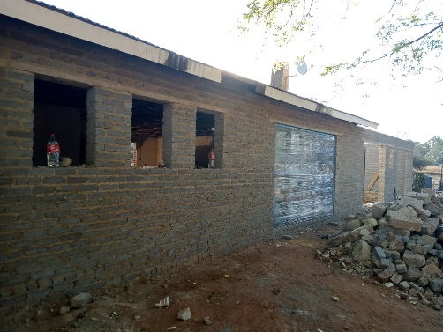  Roof  Propped, secured and rotting beams replaced  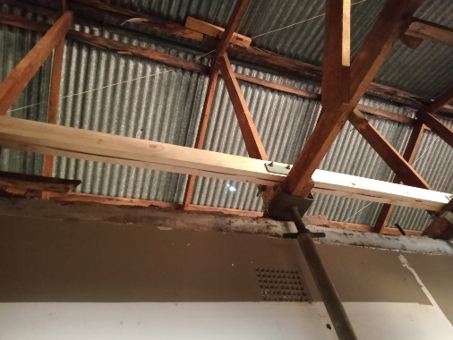  Plumbing and electrical  All old stuff removed and redone from scratch  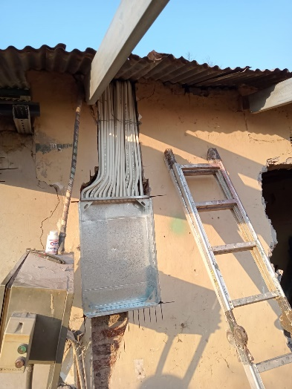  Additional rooms and internal walls  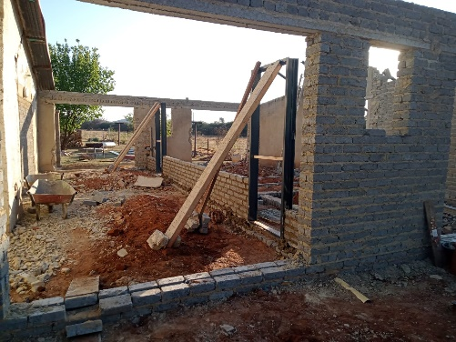  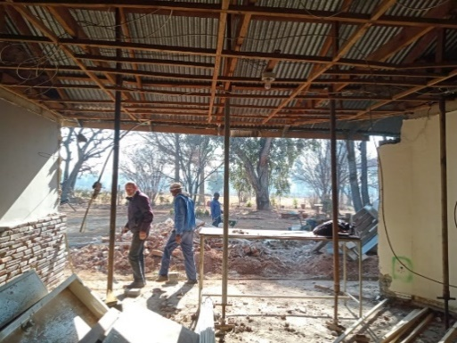  We are so excited to finish this much needed venue. Imagine the possibilities – the gospel will be spread and lives will be changed.  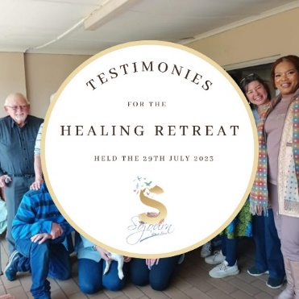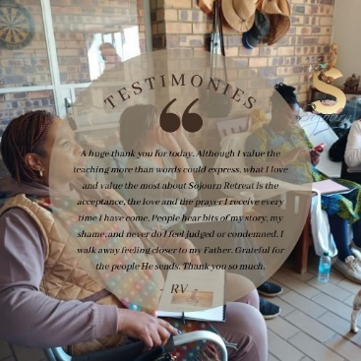  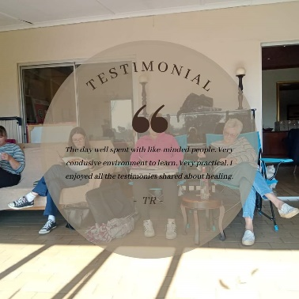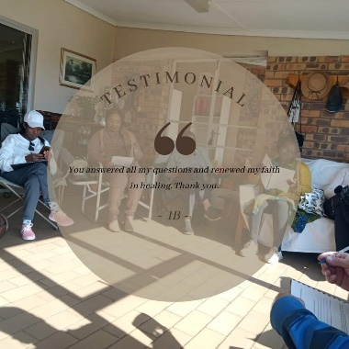  Don’t forget to book your Sojourn pop up event. An opportunity for you to host your friends and family in the comfort of your own home where we will provide solid teaching and the opportunity to discuss some really good topics. These are exciting times and what a privilege to be able to share and enjoy the gospel. See you there.  OUR WEBSITE IS LIVE  www.sojourn.org.za  AND  OUR FACEBOOK PAGE IS LIVE  https://www.facebook.com/SojournRetreatHouse  Please like, share and follow  Should you be missing our short weekly devotional, which we post on both Whatsapp and Facebook, please contact me on (0847024313) so that I can add you to the distribution list.  PRAYER REQUESTS WHATSAPP 0847024313 | 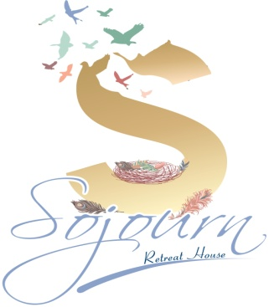  VISION  TO PROVIDE THE PERFECT ENVIRONMENT FOR PEOPLE TO ENCOUNTER GOD AND HEAR THE GOSPEL.  EQUIPPING PEOPLE, THROUGH TEACHING, TO SPREAD THE GOSPEL  BANKING DETAILS  RETREAT KINGDOM BUILDERS  FNB – CHEQUE ACCOUNT  63041139387  REFERENCE : YOUR NAME  Every cent gets us closer to our goal . Please consider becoming a monthly or once off donation partner.  I finish my 4th year at Charis Bible College at the end of October 2023.  This year was a Directorship Training Program and I am thrilled to have been a part of it. Charis is a very special place with a unique approach to teaching the gospel. I am so grateful for the awesome priviledge of having studied through them.  Thank you for your support – your prayers, encouragement and financial donations have made all of this possible. And I couldn’t do any of it without you.  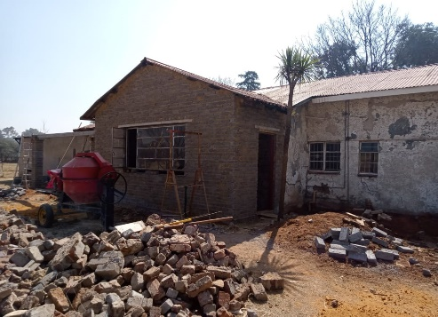  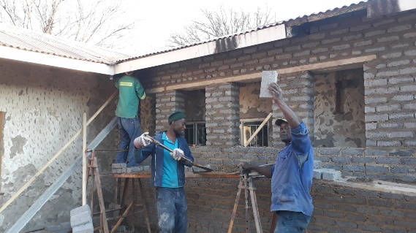  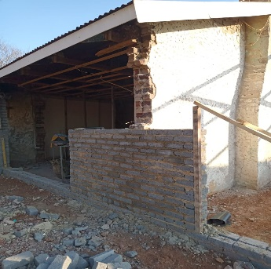  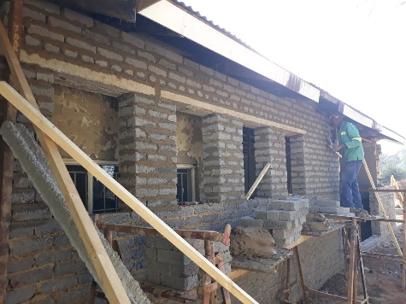  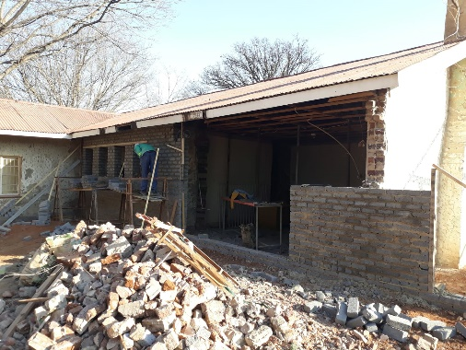  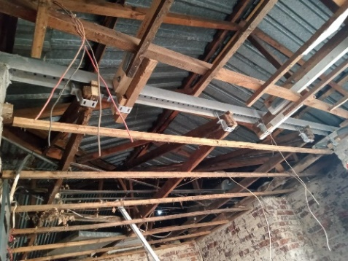  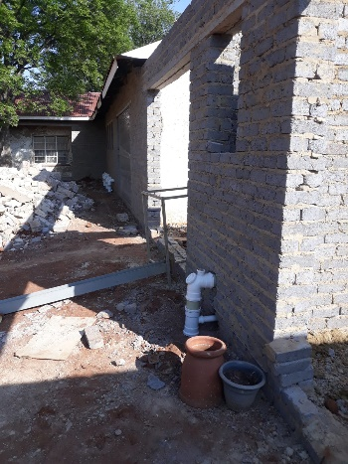  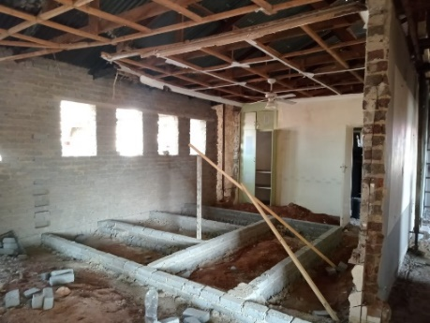  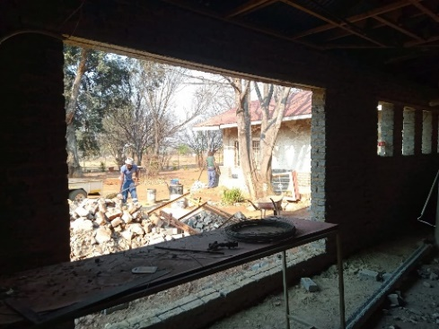  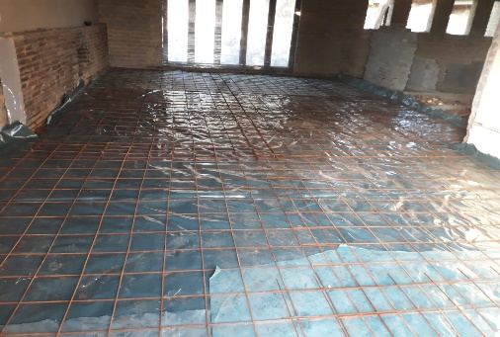  EVENT FEEDBACK  Day Retreat - In Christ – We have healing  When Jesus died on the cross He made so much available to us as born again believers. When we read the Word we begin to realise who we are and what we have in Christ. This retreat taught on healing.  And this was our most impactful retreat thus far. (See testimonies).  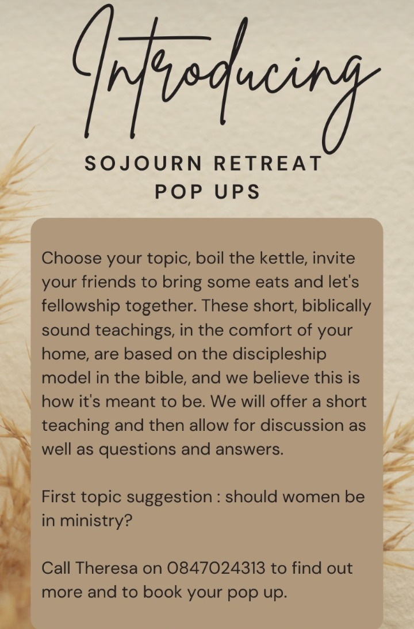  What an incredible privilege to spearhead this God- given dream.  We want you to be a part of this wonderful opportunity to invest in the lives of the people that will be transformed at the future Sojourn Events. Not everyone is called to be a pastor or teacher or even to open a retreat house. But as a financial partner, you can have a stake in every life that is touched through Sojourn. Please prayerfully consider donating towards our building fund. No amount is too small and it’s incredible how quickly it all adds up to make a difference.  We would be so honoured to have you come alongside us and partner with us.
  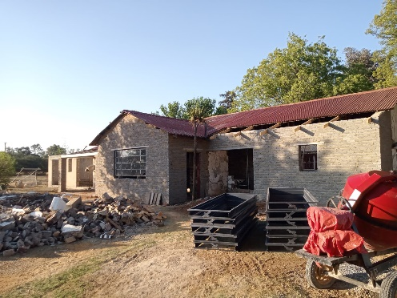

Stay a while – TESTIMONY
If there’s one thing this Retreat House Project has taught me, it’s that God is so faithful and I can see His hand in everything that He does. There are the small things that can so easily go unnoticed if I don’t immediately acknowledge them. In fact, I’ve started a journal to make sure I don’t forget them – and I’ll explain why that’s important shortly. But then there’s the big things – pure supernatural miracles that are impossible to forget. And yet, I still write them down.
A testimony is an account of what a person has seen or experienced. For us as Christians, it’s a declaration of who Jesus Christ is and what He’s done in our lives.
The Hebrew word for Testimony is “Aydooth” and it means “Do it again with the same power and authority”.
Revelations 12 : 11 reads “They triumphed over him (the enemy) by the blood of the lamb and by the word of their testimony”.
This shows us that we are able to defeat Satan because of what happened on the cross, but also by sharing our testimony of our salvation.
The beautiful thing is that as we share what God has done in our lives, we not only inspire others but it also increases our faith – both of which stem from the hope that God can “Do it again with the same power and authority”.
I have learnt that the moment I start feeling despondent or overwhelmed with the sheer size of this project, I look for similar stories in the bible or I read the testimonies of others that have gone before me and succeeded. This inspires me because I then start believing that the same is possible for me. And it helps me stay the course – it gives me hope and builds my faith. Testimony’s demonstrate the power of God and is thus a powerful evangelical tool.
The other important thing is to write down your own testimonies because there is nothing more powerful. Apart from the above two reasons, it inspires and builds faith. The main reason is that our personal testimony is undisputable – no one can ever question your experience. And therefore no criticism or cynicism can sway you.
The word of God also tells us in Psalms 78:41-42 “Yes, again and again they tempted God, and limited the Holy One of Israel. They did not remember His power. The day when He redeemed them from the enemy” This verse highlights all the amazing things God did for the Israelites and how they forgot them all. Take note that the result is that they limited the Holy One of Israel. But even more sad is that they provoked and grieved Him.
Start sharing the goodness of God and see how it changes your life and the lives of those around you.
With Love
Theresa Binnie

